# Personas

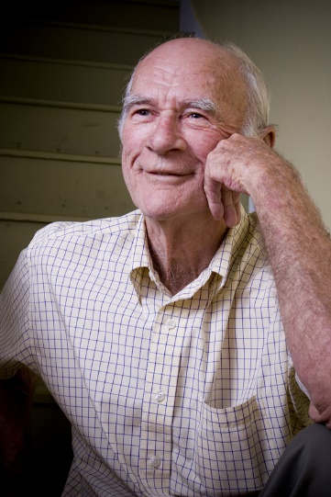Name - Bob

Age - 83

Background - European

Language - English

D.O.B – July 1 1931

Marital Status – Widowed

Computer Proficiency – Basic

Browser – IE 10

Device - Desktop

Location - rural

Profession – Miner / Engineer

Literacy – Grade 6

Internet Speed – DSL

Name - Rob

Age - 14

Background - Canadian

Language - English

D.O.B – September 13 1999

Marital Status – Single

Computer Proficiency – Advanced

Browser – Chrome

Device - Tablet

Location - rural

Profession – Student

Literacy – Grade 9

Internet Speed – Fiber

Name - Mel

Age - 35

Background - Native

Language - English

D.O.B – November 5 1979

Marital Status – Married

Computer Proficiency – Advanced

Browser – Fire Fox

Device - Laptop

Location - rural

Profession – Teacher

Literacy – PHD

Internet Speed – Fiber

# Anti-Persona

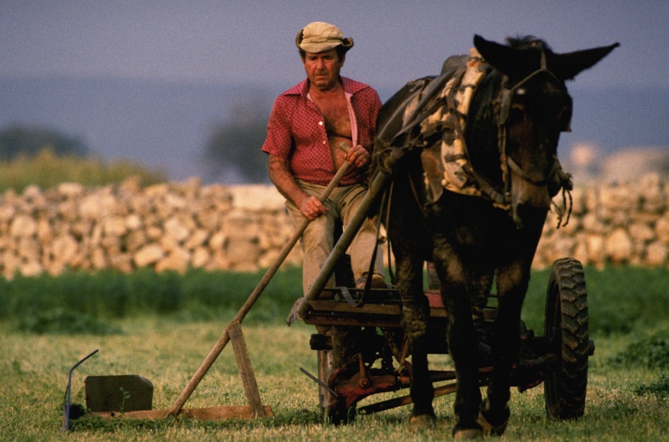

Name - Smith

Age - 65

Background - French Canadian

Language - English

D.O.B – November 5 1949

Marital Status – Married

Computer Proficiency – Poor

Browser – IE 7

Device - Desktop

Location - rural

Profession – Farmer

Literacy – High School

Internet Speed – DSL